**Dalil**

DALIL is an AI-powered platform designed to assist university students in managing their courses. It provides structured information on course descriptions, prerequisites, industry relevance, study resources, and hands-on projects. Additionally, it offers a suggested personalized semester schedule based on course availability and difficulty level. DALIL is available on Android and iOS, ensuring security through authentication and delivering high performance. With bilingual support in Arabic and English, it empowers students to plan their studies effectively and align them with market demands.

**By:**

**AMR AL-ALI**

**ELAF ALASMAR**

**HAMZAH BANI-ATA**

**HUTHAIFA AL-HAJAJ**

**MOHANNAD QASEM**

**System Request – Students’ courses Guidance**

* **Project Sponsor:** We aspire to secure funding from our college, Prince Abdullah Bin Ghazi Faculty of Information and Communication Technology. The college will provide us with financial support, as well as access to valuable information and essential resources needed throughout the development of the project.
* **Business Need:** New university students often struggle with course planning and career alignment. DALIL is an AI-powered platform that provides structured course information, prerequisites, industry relevance, study resources, and personalized semester schedules. Available on Android and iOS with bilingual support, it ensures secure access and helps students efficiently plan their studies to meet market demands.
* **Business Requirements – Specific functionality that the system should have include the following:**

1. **Course Overview** – A concise introduction to the subject with AI-generated insights tailored to the student's academic background.
2. **Course Prerequisites** – Required knowledge or courses based on the university’s major structure.
3. **Industry Relevance** – AI-driven insights on the course's impact in the job market, including emerging trends and career pathways.
4. **Study Resources –** Recommended materials and references that align with the college’s official courses and curriculum.
5. **Applicable Projects** – AI-recommended practical projects aligned with industry needs to reinforce learning categorized by difficulty.
6. **Personalized Semester Schedules** – AI-optimized course planning based on availability, difficulty, and the student's progress.

* **Business Value:** This project is a voluntary initiative designed to support our fellow students without any financial compensation. Our goal is to provide valuable guidance and resources to help them navigate their academic journey more effectively.
* **Special Issues:**

1. Curriculum Updates – As courses evolve, the system must support both old curricula for existing students and updated curricula for new students to ensure consistency and relevance.

**Requirements Analysis**

* **Functional Requirements:**

1. **Information-Oriented Functionalities:**

* **User Information:**
  + Store and manage user details, including:
    - Name
    - Email
    - Password
    - Major
    - University
    - Profile image
    - Start year
    - Completed courses
    - Ongoing courses
* **Major & College Information:**
  + Maintain structured data for each major, including:
    - Course dependency tree (showing prerequisites and sequences)
* **Course Information**

Track and display key details for each course, including:

* **Course Status** – Categorized as Completed, In-Progress, Available Later, or Pending.
* **Course Overview** – AI-generated insights providing a concise introduction to the subject.
* **Course Prerequisites** – Required knowledge or prior courses needed.
* **Industry Relevance** – AI-driven analysis of the course’s impact on the job market.
* **Study Resources** – Recommended materials aligned with the college curriculum.
* **Applicable Projects** – AI-suggested practical projects based on industry needs.
* **Personalized Semester Schedules** – AI-optimized course planning considering course availability, difficulty, and the student's academic progress.
* **Elective** or **mandatory**

**2. Process-Oriented Functionalities:**

* **Authentication:**
  + User login and registration system
  + Secure authentication methods (email/password, Auth in future versions)
* **Course Management:**
  + Ability to update course status (completed, in progress, available later, pending)
  + Track progress and suggest next courses based on prerequisites
* **Major Management (Future Versions):**
  + Allow users to change their major while preserving relevant course progress
* **Course Exploration:**
  + View details of courses that can be attended in the next semester
  + Search for other courses and access their content, prerequisites, industry relevance, study resources, and applicable projects
* **Multiple Languages Supported:**
  + Support both **Arabic and English** for the interface and study resources.
* **Non-Functional Requirements:**

1. **Operational Requirements:**
   * The system should be accessible on **mobile devices** running **Android and iOS**.
2. **Performance Requirements:**
   * Ensure **high speed and reliability**, with the system available **24/7**.
3. **Security Requirements:**
   * Protect user data confidentiality through **secure authentication mechanisms**.

**Dalil Use case Diagram**

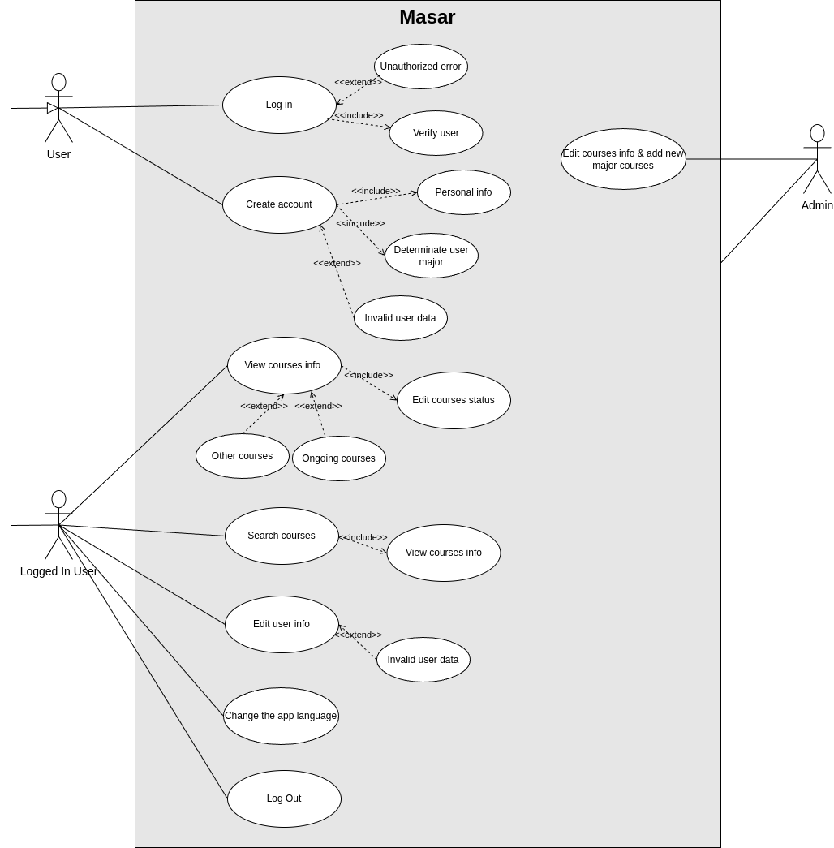

**Dalil Use case Specification**

|  |  |
| --- | --- |
| **Use Case Name** | User log in |
| **Summary Description** | Allow User login to the system |
| **Preconditions** | User must enter username and password |
| **Post conditions** | Must store username and password to remember. |
| **Actors** | User |
| **Trigger** | User enters username and password |
| **Main flow** | 1. User enters username 2. User enters password 3. User chooses “log in” 4. System verifies the credentials 5. User goes to the main screen |
| **extensions** | 4a Invalid username or password  4a1 System Display Error Message.  4a2 Redirect to step 1. |

|  |  |
| --- | --- |
| **Use Case Name** | Create Account |
| **Summary Description** | Allow User to create account in the system |
| **Preconditions** | User must be student in a university |
| **Post conditions** | Must store user info in database. |
| **Actors** | User |
| **Trigger** | User creates account |
| **Main flow** | 1. User enters username 2. User enters password 3. User chooses “Sign Up” 4. System verifies the credentials 5. User goes to the main screen |
| **extensions** | 4a Exist username or password  4a1 System Display Error Message. 4a2 Redirect to step 1. |

|  |  |
| --- | --- |
| **Use Case Name** | View Courses Info |
| **Summary Description** | Allow User to View Courses Info |
| **Preconditions** | User must be logged in |
| **Post conditions** | Empty |
| **Actors** | User |
| **Trigger** | User log in |
| **Main flow** | 1. User Choose Course 2. User View Info of Course |

|  |  |
| --- | --- |
| **Use Case Name** | Search on Course |
| **Summary Description** | Allow User to Search on Specific Course |
| **Preconditions** | User must be logged in |
| **Post conditions** |  |
| **Actors** | User |
| **Trigger** | User log in |
| **Main flow** | 1. User Choose Course 2. User View Info of Course |

|  |  |
| --- | --- |
| **Use Case Name** | Edit Course Status |
| **Summary Description** | Allow User to Edit Status of Specific Course |
| **Preconditions** | User must be logged in |
| **Post conditions** | Update Course Status |
| **Actors** | User |
| **Trigger** | User Change Status of Course |
| **Main flow** | 1. User Choose Course 2. User Change Status of Course |

|  |  |
| --- | --- |
| **Use Case Name** | Update Password if Forgotten |
| **Summary Description** | Allow User to Update Password if forgotten |
| **Preconditions** | User must enter username |
| **Post conditions** | Update password of user |
| **Actors** | User |
| **Trigger** | User Choose forgot password |
| **Main flow** | 1. User Choose forgot password 2. User Enter username 3. User enters new password 4. User enters confirmation of password 5. Update the password |
| **extensions** | 4a Password not equal of  Confirmation password  4a1 Show Error Message  4a2 Redirect to step 4 |

|  |  |
| --- | --- |
| **Use Case Name** | Change the app language |
| **Summary Description** | Allow User to change the language of the app |
| **Preconditions** | User must login |
| **Post conditions** | Update the language of app |
| **Actors** | User |
| **Trigger** | User changes the language of app |
| **Main flow** | 1. User Choose “Change Language” 2. User chooses the language needs to change to it. 3. Change the language |

|  |  |
| --- | --- |
| **Use Case Name** | Log Out |
| **Summary Description** | Allow User to log out from the System |
| **Preconditions** | User must be logged in |
| **Post conditions** | Empty |
| **Actors** | User |
| **Trigger** | User Choose “log out” |
| **Main flow** | 1. User Choose logout 2. User exit from the app |